Factor Analysis

Notes
Output Created |  | 28-JUN-2021 14:04:50
Comments
Input | Data | /Users/coderlax/Desktop/EO Hackathon/Asia/Quality of Life/COVID/Zscore/Z2.sav
Input | Active Dataset | DataSet7
Input | Filter | <none>
Input | Weight | <none>
Input | Split File | <none>
Input | N of Rows in Working Data File | 86
Missing Value Handling | Definition of Missing | MISSING=EXCLUDE: User-defined missing values are treated as missing.
Missing Value Handling | Cases Used | LISTWISE: Statistics are based on cases with no missing values for any variable used.
Syntax |  | FACTOR  /VARIABLES ZGrcocery ZTransit ZResidential  /MISSING LISTWISE  /ANALYSIS ZGrcocery ZTransit ZResidential  /PRINT UNIVARIATE INITIAL CORRELATION KMO EXTRACTION ROTATION  /FORMAT SORT  /PLOT EIGEN  /CRITERIA FACTORS(3) ITERATE(25)  /EXTRACTION PC  /CRITERIA ITERATE(25)  /ROTATION VARIMAX  /METHOD=COVARIANCE.
Resources | Processor Time | 00:00:00.18
Resources | Elapsed Time | 00:00:00.00
Resources | Maximum Memory Required | 1984 (1.938K) bytes

Descriptive Statistics
 | Mean | Std. Deviation | Analysis N
ZGrcocery | 3.5524005 | 1.00000079 | 86
ZTransit | 3.2799605 | 1.00000009 | 86
ZResidential | 1.7377009 | .99999981 | 86

Correlation Matrix
 |  | ZGrcocery | ZTransit | ZResidential
Correlation | ZGrcocery | 1.000 | .037 | .239
Correlation | ZTransit | .037 | 1.000 | -.783
Correlation | ZResidential | .239 | -.783 | 1.000

KMO and Bartlett's Testª
Kaiser-Meyer-Olkin Measure of Sampling Adequacy. |  | .404
Bartlett's Test of Sphericity | Approx. Chi-Square | 96.331
Bartlett's Test of Sphericity | df | 3
Bartlett's Test of Sphericity | Sig. | <.001

a. Based on correlations

Communalities
 | Raw |  | Rescaled
 | Initial | Extraction | Initial | Extraction
ZGrcocery | 1.000 | 1.000 | 1.000 | 1.000
ZTransit | 1.000 | 1.000 | 1.000 | 1.000
ZResidential | 1.000 | 1.000 | 1.000 | 1.000

Extraction Method: Principal Component Analysis.

Total Variance Explained
 | Component | Initial Eigenvaluesª |  |  | Extraction Sums of Squared Loadings
 | Component | Total | % of Variance | Cumulative % | Total | % of Variance | Cumulative %
Raw | 1 | 1.809 | 60.312 | 60.312 | 1.809 | 60.312 | 60.312
Raw | 2 | 1.021 | 34.020 | 94.332 | 1.021 | 34.020 | 94.332
Raw | 3 | .170 | 5.668 | 100.000 | .170 | 5.668 | 100.000
Rescaled | 1 | 1.809 | 60.312 | 60.312 | 1.809 | 60.312 | 60.312
Rescaled | 2 | 1.021 | 34.020 | 94.332 | 1.021 | 34.020 | 94.332
Rescaled | 3 | .170 | 5.668 | 100.000 | .170 | 5.668 | 100.000

Total Variance Explained
 | Component | Rotation Sums of Squared Loadings
 | Component | Total | % of Variance | Cumulative %
Raw | 1 | 1.052 | 35.080 | 35.080
Raw | 2 | 1.017 | 33.910 | 68.990
Raw | 3 | .930 | 31.010 | 100.000
Rescaled | 1 | 1.052 | 35.080 | 35.080
Rescaled | 2 | 1.017 | 33.910 | 68.990
Rescaled | 3 | .930 | 31.010 | 100.000

Extraction Method: Principal Component Analysis.
a. When analyzing a covariance matrix, the initial eigenvalues are the same across the raw and rescaled solution.

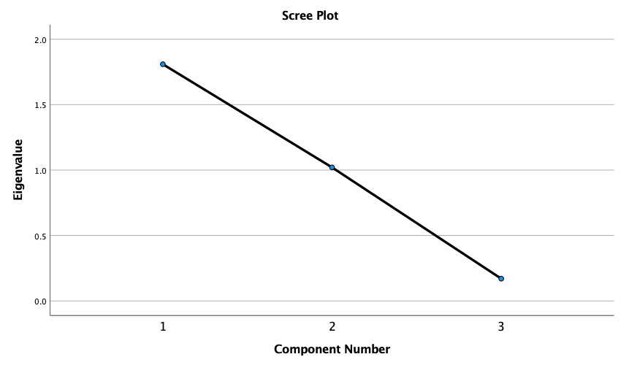

Component Matrixª
 | Raw |  |  | Rescaled
 | Component |  |  | Component
 | 1 | 2 | 3 | 1 | 2 | 3
ZResidential | .956 | .038 | .290 | .956 | .038 | .290
ZTransit | -.915 | .293 | .278 | -.915 | .293 | .278
ZGrcocery | .240 | .966 | -.096 | .240 | .966 | -.096

Extraction Method: Principal Component Analysis.ª
a. 3 components extracted.

Rotated Component Matrixª
 | Raw |  |  | Rescaled
 | Component |  |  | Component
 | 1 | 2 | 3 | 1 | 2 | 3
ZTransit | .908 | .057 | -.416 | .908 | .057 | -.416
ZGrcocery | .027 | .994 | .106 | .027 | .994 | .106
ZResidential | -.477 | .161 | .864 | -.477 | .161 | .864

Extraction Method: Principal Component Analysis.
Rotation Method: Varimax with Kaiser Normalization.ª
a. Rotation converged in 5 iterations.

Component Transformation Matrix
Component | 1 | 2 | 3
1 | -.708 | .189 | .681
2 | .269 | .963 | .013
3 | .653 | -.192 | .732

Extraction Method: Principal Component Analysis.
Rotation Method: Varimax with Kaiser Normalization.

